- Created two EC2 server one with Linux and Windows
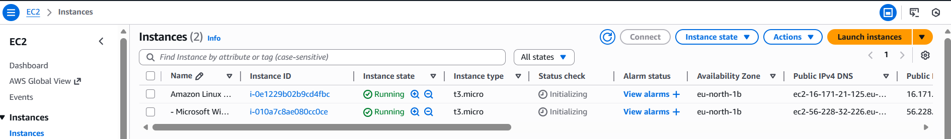

- Connected to both the EC2 servers
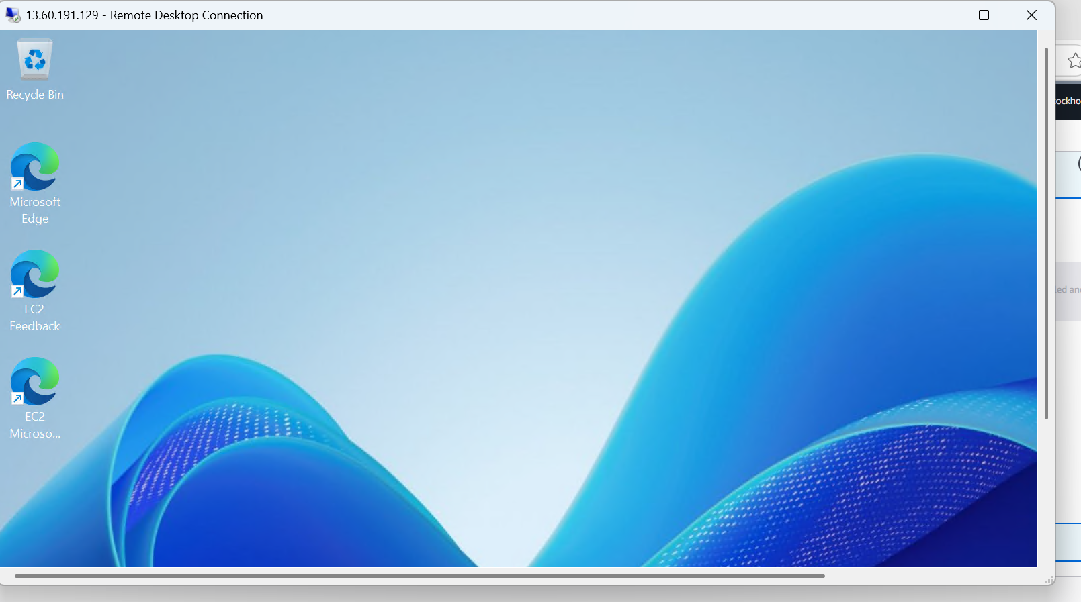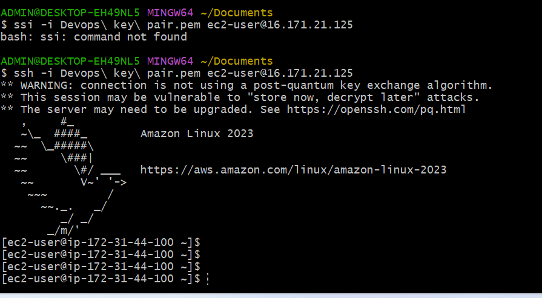
- Installed Apache and launched 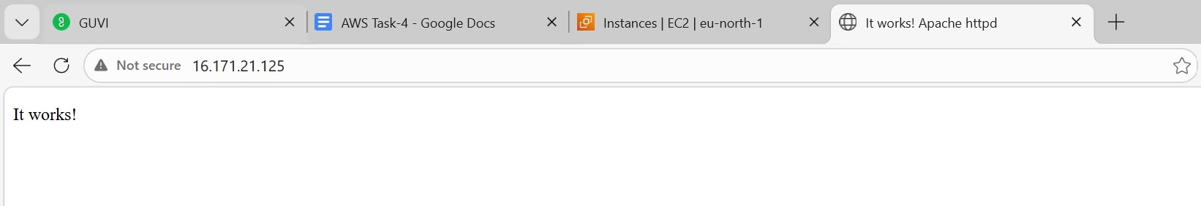
- On Windows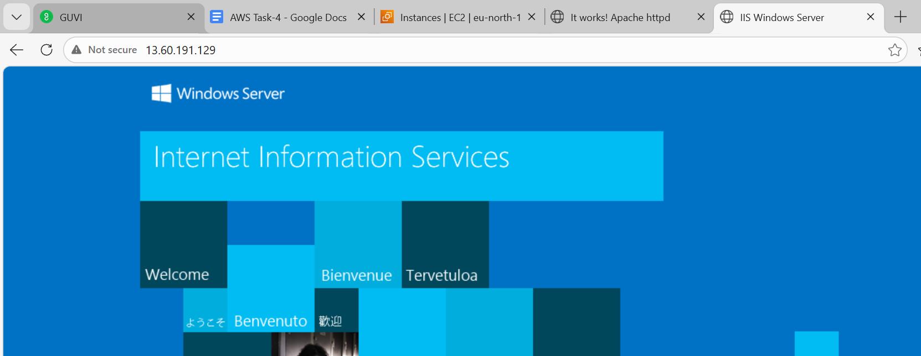
- Created two EBS Volume
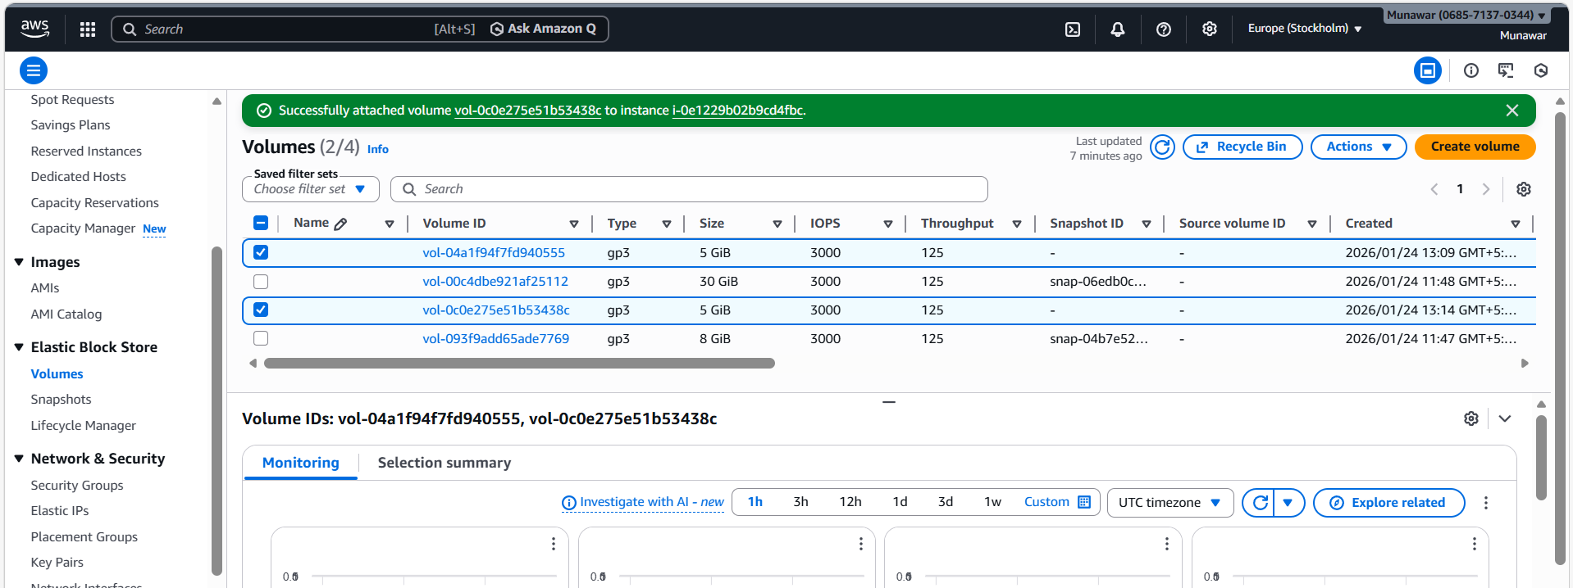
- Created snapshots and create an EBS volume using the taken snapshot.
